**Leader Overview**

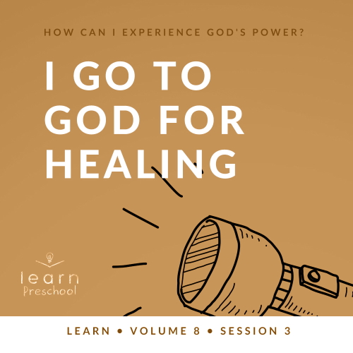

**Volume Overview**

**How can I experience God’s power?**

*When we think of power, we might think of physical strength or mental toughness. While God surely wants us to experience physical health and clarity of mind, He desires that we experience His supernatural power too.*

*In the Bible, it’s clear that our God—revealed through the Father, the Son and the Holy Spirit—is powerful. He spoke the world into existence and sustains the universe by the power of His Word (*[*Hebrews 1:3*](https://ref.ly/logosref/Bible.Heb1.3)*). God displayed His power in many ways in the Old Testament for His people. In the New Testament, Jesus’ life and works revealed His power over sickness, spiritual forces, and even the grave. After Jesus’ resurrection, God sent the Holy Spirit so we could have the power to do kingdom work today (*[*Acts 1:8*](https://ref.ly/logosref/Bible.Ac1.8)*). Clearly, God is powerful! But how do you and I experience His power? That’s the question we’ll explore in this volume.*

**Session Overview**

**I Go to God for Healing**

*Preschoolers will explore God’s supernatural ability to heal in this* **Learn** *session. We see God healing hearts and bodies in the Old Testament as well as the New Testament. God is still the same today, and we can believe and trust in His ability and desire to heal what is broken in our life.*

**Bible Lesson**

Naaman’s Healing

[2 Kings 5:1–14](https://ref.ly/logosref/Bible.2Ki5.1-14)

**Faith Fact**

I believe God can heal.

**Faith Verse**

[John 14:12](https://ref.ly/logosref/Bible.Jn14.12) (NLT)

“I tell you the truth, anyone who believes in me will do the same works I have done.”

**Preparing for the Session**

**Leader Preparation Time: 20–25 Minutes**

|  |
| --- |
| ***You Will Need***  ***Preservice Activities***  *• Toys*  *• Tray or container with small sides*  *• Four or more items used when someone is injured (bandage, gauze, ace bandage or wrap, antibiotic ointment, lotion, etc.)*  *• Small paper bag*  *• Crunchy foods like pretzels, crackers, or carrots*  ***Large Group***  *• Bible*  *• Worship songs (Song suggestions: “My God Is So Big” by Hosanna Kids; “What a Mighty God We Serve” by Christian Songs for Kids; “Love the Lord” by CJ and Friends)*  *• For groups not using a phone or tablet only, add:*  *• Projector or TV*  *• Laptop*  *•* ***Faith Fact Sound video*** *(bell ringing)*  *•* ***Faith Fact Slide***  *•* ***Faith Verse Slide***  *•* ***Bible Lesson Video A***  *•* ***Bible Lesson Video B***  ***Small Group***  *• Rolls of toilet paper, one or two per group*  *• Smartphone or other timer*  *• Large paper bag*  *•* ***Small Group Activity Page****, one per kid*  *• Crayons or markers*  *• Music player or song prepared to sing*  *• Blue plastic tablecloth(s) or blanket big enough for all the kids in the group to stand on*  *• Bandages, two per kid*  *• Small bags, one per group*  *• Red washable marker*  *• Red permanent marker, fine tip*  *To access session content and videos from a computer, visit:* [*BibleEngagementProject.com/downloads*](https://bibleengagementproject.com/downloads) |
| ***Getting Ready***  ***Preservice Activities***  *• Set out toys and snacks.*  *• Place items on the tray.*  ***Large Group***  *• Download videos and slides if needed.*  *• Select worship song(s) and have them ready to play.*  ***Small Group***  *• Print copies of the* ***Small Group Activity Page****, one per kid.*  *• Spread out the tablecloth.*  *• Color a red heart on most of the bandages with the permanent marker, one per kid.*  *• Put all the bandages in the bag.*  *• Use a washable marker to draw “sores” on the leader.*  ***First time leading* Learn *for Preschool? Check out the*** [**Facilitator Guide**](https://0b769b0ed3569ef9d18b-f88d8272f61086866d50d048b43ef630.ssl.cf2.rackcdn.com/sites/biblengagementproject/Listen_Facilitator_Guide.pdf)**.** |

**Preservice Activities**

*See what’s needed at the beginning of the session.*

**Bible Story Warm-Up**

What are some ways our bodies can get hurt? *(Allow responses.)* We have places on the inside that can get hurt. We have lungs that breathe for us. *(Place hand over your lungs and take a deep breath.)* Can you feel your lungs expand when you take a deep breath? *(Group response)* Our stomach helps our body get what we need from food. *(Place hand over your stomach.)*

• *Ask these questions. Point to the body parts when appropriate.*

What does our brain do for us?

What do our bones do?

What about our skin? How does it help us?

Today, we’re exploring a Bible story about a man who had a lot of sores on his skin. Have you ever had a sore on your skin? *(Group response)* Did it heal and go away? *(Group response)* This man’s sores wouldn’t heal on their own, and he was in a lot of pain. He needed help with his sores. I have some things I want to show you.

• *Pull out the tray with the bandage, gauze, antibiotic ointment, lotion, etc.*

• *Point to each item and name it. Instruct kids to repeat the name after you.*

What do we use these for? *(Group response)* I want you to put on your thinking caps *(demonstrate putting on a hat)* and try to remember what’s on this tray. Let’s name them one more time.

• *Point at and name each item again.*

Now, I’m going to take one item off the tray, and you’ll try to figure out what is missing. Close your eyes, so you can’t see what I’m doing. *(Group response)*

• *Put the tray on your lap in case anyone is looking while you put one item into the bag.*

In a moment, I’ll ask you to open your eyes. When I do, I want you to pretend you have a bubble in your mouth. That means you can’t talk while you look at the tray. I’m going to count to ten while everyone has a chance to look at the tray and think about what’s missing. Remember, I don’t want you to shout out your answers until everyone has had time to think about it. Go ahead and open your eyes and look at the tray.

• *Show tray to the kids. Count to ten silently.*

Okay, now tell me what’s missing from the tray. *(Allow responses.)* Good job! Let’s do it again. I’m going to take something else off the tray.

• *Remove another item and repeat procedure.*

• *Each time ask kids what was taken off previously as well.*

• *Keep playing until nothing is left on the tray.*

Can you remember all the things that were on the tray now that it’s completely empty? Let’s see if you can name everything. *(Allow responses.)* Together you remembered everything! What a great team you are!

Our Bible story is about a man who had a good team of people around him. They helped him go to the prophet Elisha and ask God to heal his sores. Do you think God healed the man in our Bible story? *(Group response)* He did! We serve a God who heals. I think Lizzy will tell us more about that later.

**Snack**

**Crunchy Foods (pretzel sticks, crackers, etc.)**

We’re talking about our skin today, and our skin helps us with one of our five main senses. Our skin helps us to feel things that we touch. Our senses are how our body understands the world around us. I’m going to point to a body part, and you tell me what we use it for.

• *Touch your nose. (Group response)*

• *Touch your ears. (Group response)*

• *Touch your eyes. (Group response)*

• *Wiggle your fingers. (Group response)*

• *Point to your tongue. (Group response)*

We use our tongues to taste things. I wonder what we could do now to use our sense of taste. Does anyone have any ideas? *(Group response)* Let’s eat our snack.

• *Give kids the snacks.*

• *As kids are eating the snack, share the following.*

Our tongues are pretty interesting because they have taste buds to tell us how things taste. Our tongues are also like our skin, and they tell us how things feel.

Have you ever eaten something really smooth like ice cream? *(Group response)* Your tongue tells you that it’s smooth.

What foods feel bumpy?

How would you describe our snack today?

**Free Play**

*Any extra time can be spent playing with toys.*

**Transition**

*A few minutes before service begins have kids make their way to the large group area and sit in their designated areas.*

**Large Group**

**25 Minutes**

*See what’s needed at the beginning of the session.*

**Introduction**

I’m so excited to be with you today! Why do we come to church? *(Allow responses.)* We come to learn more about who God is and what He says in His Word. *(Hold up Bible.)* One difference about this Book from many other books is that the Bible is true. If the Bible says something happened, we know it really did. Today, we’ll discover that God healed a man with sores on his skin. I want everyone to touch the skin on your arms. *(Group response)* Because God healed many people in the Bible, we know that God can heal us.

**Faith Fact**

That’s why our Faith Fact today is **I believe God can heal.**

• *Show the* ***Faith Fact Slide.***

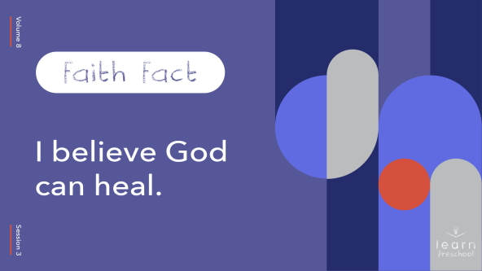

Say it with me. **I believe God can heal.** When we’re sick or hurt in some way, God can heal every part of our body. Let’s touch our feet and say our Faith Fact. **I believe God can heal.** Let’s touch our knees and say it one more time. **I believe God can heal.** Let’s touch our arms and say it one last time. **I believe God can heal.** God is so amazing! He made all of our bodies, and He can heal them.

**Bible Time**

Are you ready to hear about how God healed the man with sores? *(Group response)* Then let’s visit Lizzy because she’s got a great Bible story for us!

• *Play* ***Bible Lesson Video A****.*

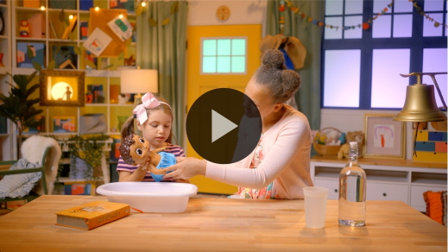

You did a great job helping Lizzy solve the clues, and you did an even better job at listening to the Bible story. I love that the Bible shows us God can heal us. God heals our heart of pain and disappointment, and God heals our body of sickness and sores.

**Worship**

Wave your hand at me if you’ve ever fallen on the sidewalk or playground and gotten hurt. *(Group response)*

• *Modify the story to fit your childhood story of who took care of you.*

When I was your age and I got hurt, my mom would take care of me. She’d get a bandage and tell me that she was going to help me. Who takes care of you when you get hurt? *(Allow responses.)*

God can take care of us in an even better way than anyone else can. Who in your life loves you the most? *(Allow responses.)* God loves you more than that person. He loves you more than you can even understand. When we need healing, He comforts and cares for us. Let’s take some time to thank God for how much He loves us.

**Praise**

Are you glad God loves you? Wave your hands up high. *(Group response)*

Are you happy God heals you? Point to a place on your body that you’ve hurt before. *(Group response)*

Who wants to tell God thank You for healing your body? Clap your hands. *(Group response)*

**Sing**

One way we worship God is by singing. When you sing, I’m not the only one who can hear you. God hears you and sees your heart of worship.

• *Lead the kids in singing one or two songs. See song suggestions at the beginning of the session.*

**Prayer**

Let’s take some time to focus on praying for healing. You may need healing in some way. Maybe you have a friend or family member who needs healing. While we pray, touch the part of your body that you want God to heal for yourself or someone else.

• *Pause while kids respond.*

|  |
| --- |
| God, thank You for how deeply You love us. You heal our body, and You heal our heart. We pray for the people in this room and for the people we love who need healing today. You are so good to us, and we praise You for that. Amen. |

**Bible Time cont’d**

I wonder what Lizzy has been up to while we worshipped God and prayed. Should we check in with her to see if she’s ready to practice the Faith Verse with us? *(Group response)*

• *Play* ***Bible Lesson Video B.***

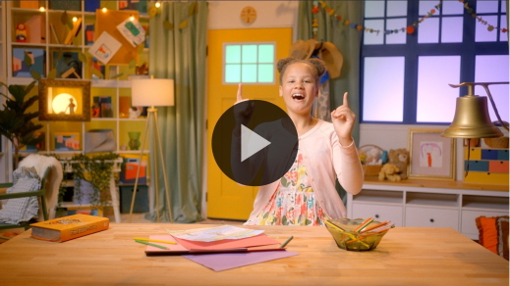

I love that we’re planting God’s Word in our heart. I’m learning the Faith Verse just like you are. The Faith Verse reminds me that God wants to use me to help people like God used Elisha to help heal Naaman.

**Response Time**

• *Play a worship song quietly.*

In our Bible story today, Naaman needed to be healed. What was wrong with his body? *(Allow responses.)* What did Elisha tell him to do in order to be healed? *(Allow responses.)* Does anyone remember how many times Naaman needed to dip in the Jordan River? *(Allow responses.)* Let’s crouch down and stand up seven times like we’re Naaman. Count with me!

• *Crouch and stand seven times.*

Now that we have reviewed the story, let’s take some quiet time to respond to what we’ve learned today. Hold your hands out and open like you’re waiting to get something. God wants to give us healing, and He wants to carry our pain for us. Let’s pray.

• *Optional: Have the kids repeat phrases of the prayer after you.*

|  |
| --- |
| God, my heart needs healing. My body or someone I love needs healing. Thank You for caring about everything I feel. Thank You for healing us and loving us. Amen. |

**Faith Verse**

One of the ways God speaks to us is through His Word, the Bible. The more Bible verses we have in our heart, the more they can help us when we need them. Let’s say our Faith Verse and do the actions together.

[John 14:12](https://ref.ly/logosref/Bible.Jn14.12) (NLT)

“I tell you the truth, anyone who believes in me will do the same works I have done.”

• *Show the* ***Faith Verse Slide****.*

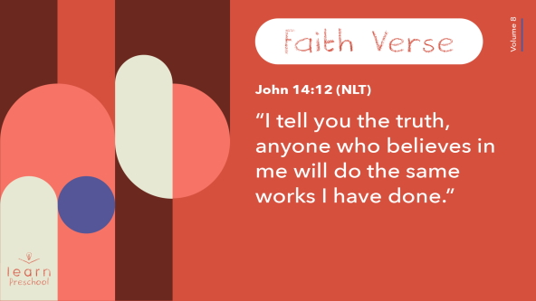

God created your brain to remember so well. You’re getting that Faith Verse down!

**Closing**

I had a great time today exploring how God heals us. The next time you see a bandage think about God healing Naaman’s skin from all those painful sores.

• *Play the* ***Faith Fact Sound*** *video (bell ringing).*

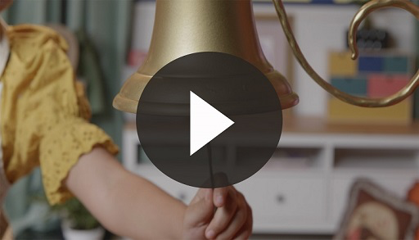

That sounds means it’s time to practice our Faith Fact again. **I believe God can heal**.

• *Show the* ***Faith Fact Slide.***



Since God can heal our body, let’s wiggle and jump around while we say our Faith Fact one last time. **I believe God can heal.**

**Dismissal to Small Groups**

Great job! Now, it’s time to head to our small groups.

• *Dismiss the kids by groups*.

|  |
| --- |
| ***Leader Tip****: This can be done by assigning color teams or by age groups. Note that some young preschoolers may not know their age. Using a colored sticker, jersey, or wristband will help separate the kids and help identify their small groups.* |

**Small Group**

**25 Minutes**

*See supplies and prep instructions at beginning of session or in each activity below.*

|  |
| --- |
| ***Leader Tip:*** *Small groups can alternate to each circle, or all groups can do each activity at the same time. If you choose to alternate, you will need at least one leader per circle.* |

**Circle 1**

**Group Connection**

**Toilet Paper Wrap**

|  |
| --- |
| ***You Will Need***  *• Rolls of toilet paper, one or two per group*  *• Smartphone or other timer*  *• Large paper bag*  *No prep is needed for this activity* |

What part of Naaman needed healing? *(Group response)* Yes, he had sores on his skin. What do we do when we have a sore? *(Allow responses.)* One thing sores usually need to heal is to be covered. Let’s play a game. One of you will pretend to be Naaman. The rest of us are going to help take care of your sores by wrapping toilet paper around your shoulders, arms, body, and legs. Let’s see how much toilet paper we can quickly wrap around our sick friend.

• *Choose someone to be Naaman.*

• *Demonstrate how kids can walk around Naaman to wrap him with the toilet paper.*

Are you ready to help Naaman? *(Group response)* Let’s go!

• *Set a timer for two minutes.*

Now, Naaman has his sores covered, but he still needs to be healed. Who can help us with that? *(Allow responses.)* That’s what our Faith Fact says. Let’s shout our Faith Fact together. **I believe God can heal.** That sounded so great! Because God can heal, let’s have Naaman rip off the toilet paper and reveal healed skin. Praise God that He heals!

• *If there’s time, let another kid be Naaman and do the activity again.*

I’ve seen how fast you all can move your hands, so let’s see how quickly we can pick up all the toilet paper and put it into this bag. Do you think we can pick it all up in less than one minute? *(Group response)* I’m going to set my timer so that we can know. Ready, set, go!

• *Set timer. Call out by name those who are working hard.*

• *Celebrate the time after the job is done.*

**Circle 2**

**Activity Page Time**

**Naaman’s Healing**

|  |
| --- |
| ***You Will Need***  *•* ***Small Group Activity Page****, one per kid*  *• Crayons or markers*  ***Getting Ready***  *• Print copies of the* ***Small Group Activity Page****, one per kid.* |

Let’s think about our Bible story. What did Naaman have on his skin when he first went to the Jordan River? *(Group response)* Yes! He had lots of sores on his skin.

• *Hand out a copy of the* ***Small Group Activity Page*** *to each kid.*

What do you see on this paper? *(Allow responses.)* Let’s count how many pictures of Naaman are on our page. We’ll start counting and touch each one as we count. How many pictures are there? *(Allow responses.)*

• *Demonstrate starting at top left and counting each face as you move left to right on each row.*

There are seven pictures of Naaman. Was seven an important number in our Bible story? *(Group response)* You’re right! That’s how many times Elisha told Naaman to dip into the water. Did God heal Naaman the first time he dipped in the river? *(Group response)* Then, draw sores on Naaman and give him a frown.

• *Make sure kids followed this instruction.*

How about the next few times? Did God heal Naaman the second, third, fourth, fifth, or sixth time Naaman dipped in the water? *(Allow responses.)* No, God didn’t. Now, draw sores and a frown on all the pictures except the last one.

• *Help kids follow this instruction.*

When you get to this last picture, does Naaman have any sores? *(Group response)* Naaman’s face is healed of all his sores. I think you need to draw a smile on Naaman in the last picture. Then trace over the number 7. I’m so glad God healed Naaman, and that God can heal us.

• *During the activity, interrupt and practice the Faith Fact:* **I believe God can heal.**

• *Play the* ***Faith Fact Sound*** *video. Review the Faith Fact even if you can’t play the sound.*



**Circle 3**

**Feet-to-Floor Game Time**

**Run to the River**

|  |
| --- |
| ***You Will Need***  *• Music player or song prepared to sing*  *• Blue plastic tablecloth(s) or blanket big enough for all the kids in the group to stand on*  ***Getting Ready***  *• Spread out the tablecloth on the floor.* |

Have you ever played Musical Chairs? *(Group response)* Our game is like Musical Chairs, but instead of running to sit in a chair, you get to run to the Jordan River and dip in the water like Naaman.

• *Point to where the tablecloth is spread out.*

The tablecloth is the Jordan River. Let’s pretend to hear the Jordan River’s waves. Put your hand on your ear and whisper, “Swish, swish, swish.” *(Group response)* Notice that there is plenty of space for everyone in the Jordan River.

Remember, we play games to have fun with our friends. I want you to think about this question. How can I be a good friend in this game? As you’re walking in a circle to the music and then running to the river, how can you be a good friend? *(Allow responses.)* Those are such great answers!

I want you to have fun together, so I hope I don’t see anyone pushing or knocking someone down. Okay, let’s get started. We’ll walk in a circle until we hear the music stop. Then, where do we run? *(Group response)* Yes, go to the Jordan River. I think you’re ready.

• *Lead the way in the circle so that kids can follow you. Play one of the song suggestions or other preschool Bible tune while you sing and march in the circle.*

• *Stop the music and run to the river area.*

• *In the river area, count to seven with the kids as you bend down to touch the ground and then stand up. Remind them how many times Naaman dipped himself into the river.*

• *Say the Faith Fact after you count to seven.* **I believe God can heal.**

• *Repeat as time allows. Let a different kid lead the group in a circle each time.*

**Circle 4**

**Hands-On Learning**

**Bandage Naaman’s Sores**

|  |
| --- |
| ***You Will Need***  *• Bandages, two per kid*  *• Small bags, one per group*  *• Red washable marker*  *• Red permanent marker, fine tip*  ***Getting Ready***  *• Color a red heart on most of the bandages with the permanent marker, one per kid.*  *• Put all the bandages in the bag.*  *• Use a washable marker to draw “sores” on the leader.* |

Today, I’m going to be Naaman, and you’re going to help put bandages on my sores. I have a lot of bandages here in this sack. Some of them have a red heart drawn on them, and some of them don’t. I want to make sure you’re going to take good care of me.

• *Show kids a bandage with a heart on it.*

You’re going to take turns pulling a bandage out of the sack. If it has a heart on it, you get to put it on one of my sores. We’ll go around the circle until everyone picks a bandage with a heart and gets to put it on me. While you do that, we’ll say the Faith Verse together. Let’s practice it together.

[John 14:12](https://ref.ly/logosref/Bible.Jn14.12) (NLT)

“I tell you the truth, anyone who believes in me will do the same works I have done.”

• *Pass bag around the circle. Let the kids pull out bandages one at a time until they get one with a heart.*

• *Help kids open the bandage if needed and put it on you.*

• *Keep going until everyone has had a turn to add a bandage.*

Look at how many bandages Naaman needed! I am so thankful our Bible story didn’t end here. I’m glad God healed Naaman, and I’m thankful God heals us too.

• *Optional: Let kids take turns removing the bandages that they put on you.*

**Dismissal**

• *Play the* ***Faith Fact Sound*** *video (bell ringing).*



• *Show the* ***Faith Fact Slide.***



We’re going to say our Faith Fact one last time before we go. **I believe God can heal.** I had such a great time exploring the Bible with you today. See you next time!

• *Send home the* ***Small Group Activity Page*** *with each kid.*

• *Remind parents that there are* ***Family Devotions*** *available on the app to do with their kid.*

• *Tell everyone the date and time for the next session.*